**BLOCK DIAGRAM**

Push Buttons

DC Motors

ESP32-C3  
(Wireless)

ATmega328P  
(Microcontroller)

L298N Driver  
Controls Motors

+5V / +12V Power Supply

+5V for MCU

+12V for Motors

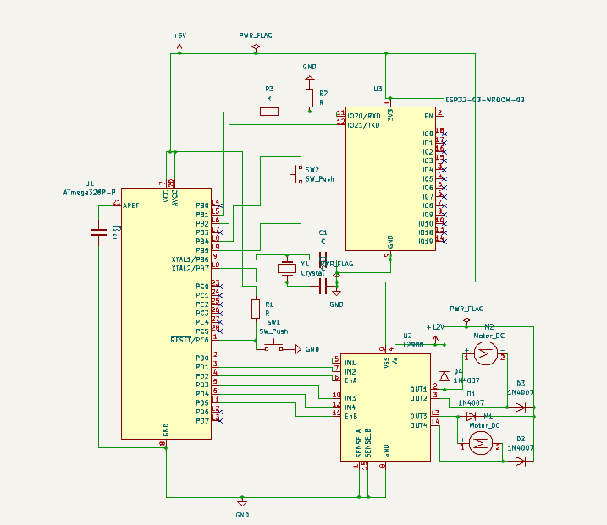SCHEMATIC DIAGRAM

**LAYOUT**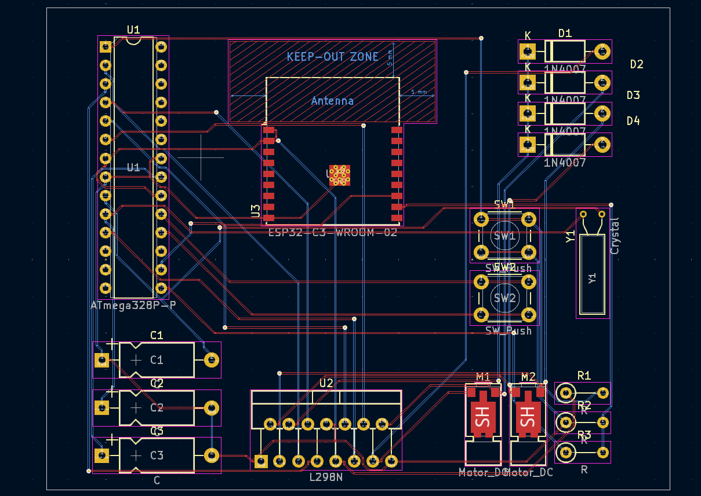

FRONT COPPER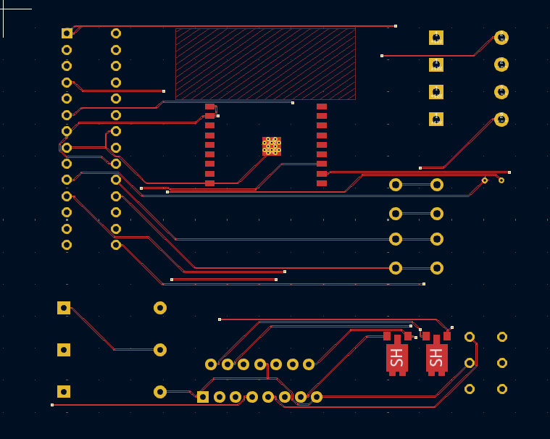

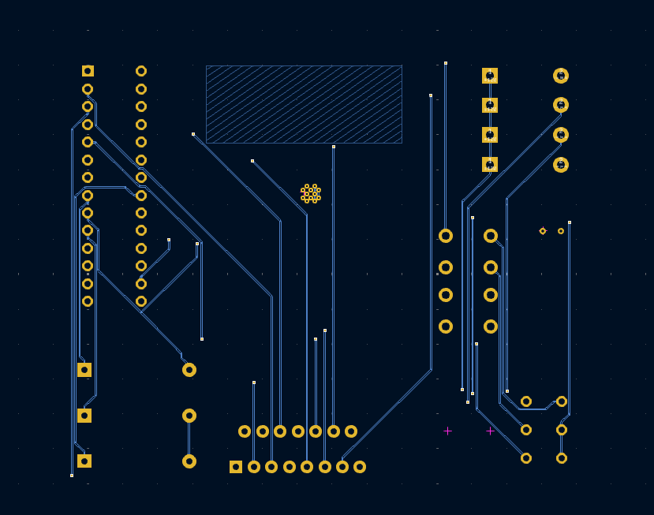BACK COPPER

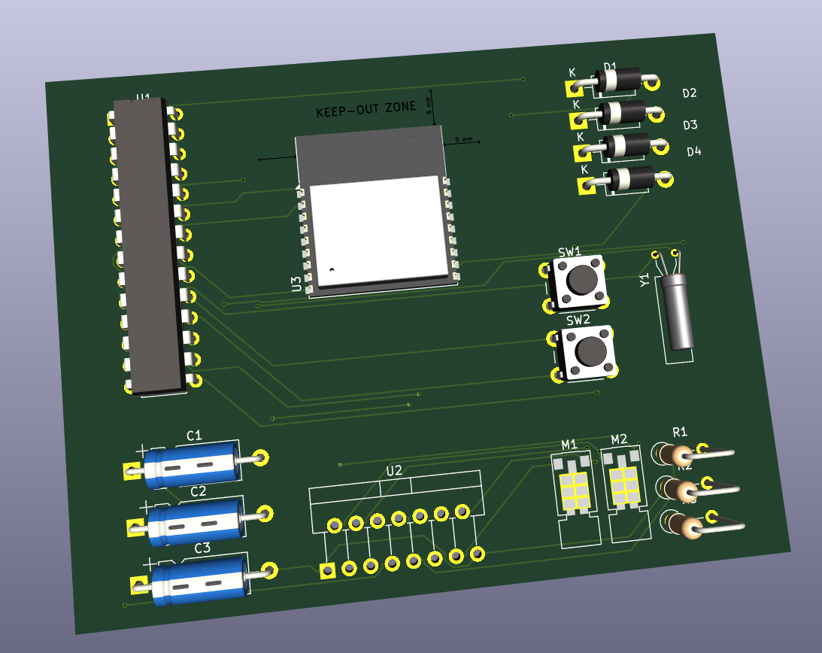**3D OF PCB**